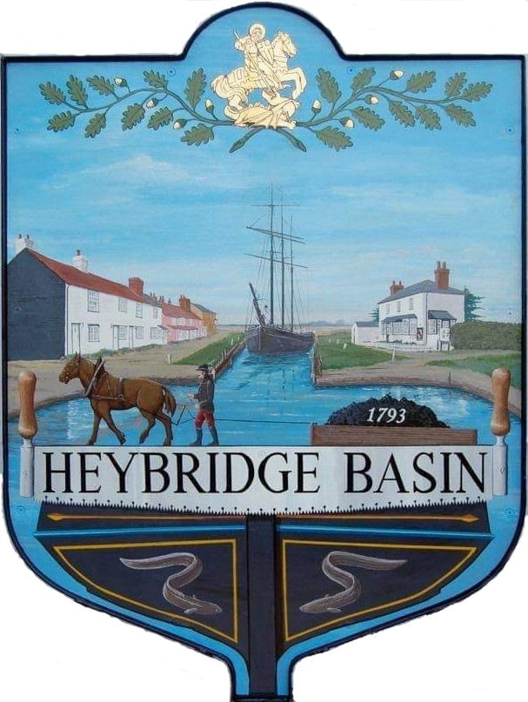

HEYBRIDGE BASIN PARISH COUNCIL

Minutes of the Full Council meeting of Heybridge Basin Parish Council held on Tuesday 10th September 2024 at 06:30pm, at The Lock Tearoom.

PRESENT

In the Chair: M. Hodges (Chair) Absent: 0

Councillors: R. Bryson (Vice Chair) Apologies: 0
J. Sjollema
M. Hobden Public: 7
G. Howat
C. Edmond District Cllrs: 2
C. Swann

Officers: G. Lake – Clerk

It was noted that this meeting was being recorded by the Clerk.

24/069 Chair’s Welcome.
The Chair opened the meeting and thanked members of the public for attending. The Chair presented on behalf of the whole Council, a personalised vase to the Clerk to commemorate and celebrate the passing of her CiLCA earlier in the year. The Chair attended the Digital Switchover event in August and advised that it was well attended and informative. It was noted that since the last meeting Maldon District Council had made planning decisions contrary to the recommendations of the Parish Council.

24/070 To note apologies for absence.
There were no apologies.

24/071 To receive Declarations of Interest in accordance with the Council’s Code of Conduct and with section 106 of the Local Government Finance Act 1992.
Cllr Hobden – Non-Pecuniary – HBSA, Basin Oars and HB River care; Cllr Edmond – Non-Pecuniary – Director of Cloughton Court Management and Essex Waterways; Cllr Howat – Non-Pecuniary – HB Conservation Society and Clint Swann – Non-Pecuniary – Owner of Tearoom Building and Pecuniary – Land near Timber Yard Development.

24/072 To sign as a correct record the minutes of the full council meeting held on 19th July 2024.
The Minutes as previously circulated were agreed as a correct record.

24/073 To sign as a correct record the minutes of the Extraordinary meeting held on 20th August 2024.
The Minutes as previously circulated were agreed as a correct record.

24/074 To receive a report from:
- District Councillors – A verbal report was given by District Cllr N. Spenceley.
- County Councillor – There was no report from Cllr Durham.

24/075 Finance.
- To approve
- Payment requests for July/August 2024
The Payment requests as previously circulated were approved.
- Receipts for July/August 2024
The receipts as previously circulated were approved.

24/076 Internal Auditor
  - To consider the quotes received and appoint an Internal Auditor for the year 2024/2025
Two quotes had been received. It was resolved to appoint April Skies as the Internal Auditor for the year 2024/2025. Cllr Howat abstained from the vote.

24/077 Public Forum (15 minutes)
Members of the Public will be given an opportunity to put forward their question(s) or statement to the Council. The Chair will at their discretion then decide if they are able to answer the question(s) or proposes to put the item on the agenda for the next meeting.

The Chair of the Heybridge Basin Conservation Society informed the Council that they are still reviewing the Timber Yard Planning Application. They have identified the importance of a village meeting as soon as possible with the PC to gather as many views and opinions as possible. The site is one of the last 2 sizeable areas for development in the village. Previous applications were called in by the former District Councillors and the Conservation society would like this application to be called in. They advised that 26th September is the final date for comments.

Another member of the public advised how residents of Chapel Lane were affected the most, but the application was the best they had seen in terms of density and what its offering to them and the village and that they were cautiously minded supporting the application but subject to assurances that the developers promise to them would materialise. Would the PC be minded taking this into consideration as part of the possible 106 agreement?

Third member of the public said that the Conservation Society never said that the site should never be developed.

24/078 Planning
- To consider any planning applications received after the publication of the agenda and to agree the action to be taken.

24/00627/HOUSE – Pilot House, 4 Maritime Avenue – Single storey side and rear extension.
It was resolved to recommend the granting of planning permission for this application.

24/00654/FULM – The Former Timber Yard – The demolition of the existing buildings and the construction of No.13 new dwellings and associated landscaping, access, car and cycle parking, and refuse and recycling provision.

- To consider the proposal from Cllr Hodges regarding the Section 106 agreement and agree any action to be taken.
It was resolved to defer item a – The Former Timber Yard to an EGM on Tuesday 17th September. It was resolved for the meeting to be structured with presentations from Govey Homes Ltd and the Heybridge Basin Conservation Society, followed by a question section for residents and Councillors with the Council making their decision on the application at the end.
- To note the Neighbourhood Planning letter from Maldon District Council (MDC)
The letter was noted.
- To review the proposed reforms to the National Planning Policy Framework (NPPF) and other changes to the planning system and respond to the consultation via SLCC (Society of Local Council Clerks)
It was resolved for members to review the document and email the Clerk comments with the view of approving a potential response at an EGM.
24/079 On Street Parking
- To review and consider submitting the application to South Essex Parking Partnership (SEPP).
It was resolved for the Clerk to post the application to South Essex Parking Partnership.

24/080 Biodiversity
- To note the reports and wildflower seed information from the visit with the Essex Wildlife Trust Ranger.
The reports and information were noted with actions to be discussed at the next meeting.
  - To consider the email regarding tree packs and agree any action to be taken.
It was resolved for the Clerk to apply for some free tree packs for potential planting in the old toilet block area or outside St George’s Church.

24/081 Maintenance in the village
- To receive an update from Cllr Bryson regarding the Noticeboard near the Jolly Sailor and agree any action to be taken.
Concerns over the damaged noticeboard post and wired fence had been resolved by a resident prior to the meeting. It was resolved to get a quote from HRS Marine Services to paint the posts. Cllr Swann abstained from the vote.
- To discuss the hedges along Basin Road and agree any action to be taken.
It was resolved for the Clerk to seek quotes to have the work completed annually and twice a year.
- To discuss the trees on the land outside St George’s Church and agree any action to be taken.
Two branches appear to be dead and unsafe. It was resolved for Cllr Swann to liaise with a tree specialist to get advice on what action is required.

24/082 Remembrance Sunday
  - To consider plans for Remembrance Sunday and agree any action to be taken.
It was resolved to host an Act of Remembrance on Saturday 9th November 2024.
  - To consider the letter from the Royal British Legion and agree any action to be taken.
The letter was requesting a donation as well as a cross which the Council could write on to be planted in one of the designated fields. It was resolved to write the names of the Basiners who had died in service on the cross and donate £50.00 to the Royal British Legion.

24/083 Daisy Meadow Car Park (DMCP)
- To receive an update from the Clerk regarding Square Cottage bridge and agree any action to be taken.
The Clerk provided a verbal update on the information which was still outstanding. The owner of the bridge was at the meeting and advised that the bridge was being removed.
- To receive a verbal report from Cllr Sjollema regarding public toilets and agree any action to be taken.
Cllr Sjollema reported that the toilet/shower blocks at the boat yard may be up for sale at a cost of £150k and considered whether these would be suitable for the Parish Council. Cllr Bryson advised members that the toilets could not be built where they were previously. It was resolved for the DMCP Working Group to investigate public toilets.

24/085 Clerk’s Report
- Speed Watch Volunteers – The Clerk announced that the Speed Watch group were still recruiting volunteers.
- Budget Meeting – The Clerk requested all members to email their availability to organise a meeting to solely discuss the budget.
- Operation London Bridge Training – The Clerk requested to attend training online with SLCC at a cost of £30.00 + VAT. It was resolved for the Clerk to attend the requested Operation London Bridge Training.
- Councillor Training – The Clerk reminded Cllrs that there was training available to them and to advise her if they would like to attend.

24/086 Correspondence
- To note correspondence received and agree any actions to be taken.
Correspondence was noted and responses were agreed.
It was resolved to donate £50.00 to Friends of Heybridge Cemetery for bulbs.
It was resolved to move the Council meetings to St George’s Community room for the remainder of the financial year to assess public attendance.
It was resolved to donate £50.00 to the Marie Curie Charity.

24/087 Pursuant to section 1(2) of the Public Bodies (Admission to Meetings) Act 1960 it is resolved that, in view of the confidential nature of the business about to be transacted, it is advisable in the public interest that the press and the public be excluded, and they are instructed to withdraw.

All members of the public left.

24/088 Goal Posts and Netball Hoop
- To receive a verbal report from the Clerk and agree any action to be taken.
The Clerk informed members that it was not a Netball Hoop that was previously in place, but a Basketball Hoop. The Clerk suggested investigating returning the Netball Hoop and purchasing a Basketball Hoop due to safety issues with the ball potentially landing in the play area, and the basketball hoop having a backing board. It was resolved for the Clerk to research the logistics and cost implications.
- To review the draft licence agreement from Maldon District Council and agree any action to be taken.
It was resolved to accept the licence agreement from Maldon District Council including the £10.00 annual fee.

There being no further business the meeting closed at 08:18pm
Provisional Date of the next Council Meeting Tuesday 15th October 2024

Clerk Contact details: clerk@heybridgebasinpc.org.uk
Website: www.heybridgebasin-pc.gov.uk

